One-Sample t-Test – Example 2 (Memory Booster) ANSWER KEY

A nutrition store in the mall is selling “Memory Booster,” which is a concoction of herbs and minerals that is intended to improve memory performance, but there is no good reason to think it couldn't possibly do the opposite. To test the effectiveness of the herbal mix, a researcher obtains a sample of 8 participants and asks each person to take the suggested dosage each day for 4 weeks. At the end of the 4-week period, each individual takes a standardized memory test. In the general population, the standardized test is known to have a mean of μ = 7.

Step 1. State your hypotheses.
a. Is it a one-tailed or two-tailed test? Two-tailed

b. Hypotheses in words
Alternative hypothesis: Those who take Memory Booster will have a significantly different memory score from that of the general population.

Null hypothesis: Those who take Memory Booster will have the same memory score as that of the general population.

c. Statistical hypotheses
H_{A}: µ_{MB} ≠ 7

H₀: µ_{MB} = 7

Step 2. Set the significance level ➔ α = .05 Determine t_{crit}. ± 2.365

Step 3. Compute the appropriate statistical test.

Memory after taking Memory Booster (X) | 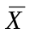 | Deviation  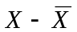 | Squared Deviation  () ²
8 | 8 | 0 | 0
9 | 8 | 1 | 1
6 | 8 | -2 | 4
8 | 8 | 0 | 0
9 | 8 | 1 | 1
8 | 8 | 0 | 0
7 | 8 | -1 | 1
9 | 8 | 1 | 1
∑X = 64  N= 8 |  |  | SS =  ∑ () ² =  8
= 8

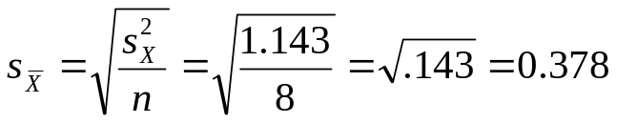

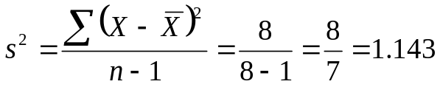

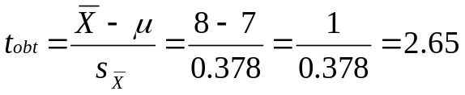

Step 4. Make a decision. Determine whether the value of the test statistic is in the critical region. Draw a picture. Label t_{crit} and t_{obt}.
Is t_{obt} in the critical region? __yes____
Should you reject or retain the H₀? reject

t_{crit} = -2.365 t_{crit} = +2.365
t_{obt} = 2.65

Step 5. Report the statistical results.

t(7) = 2.65, p < .05.

Step 6. Write a conclusion.

People who took Memory Booster had significantly higher memory scores (M = 8) than the general population (µ = 7).

Step 7. Compute the estimated d.
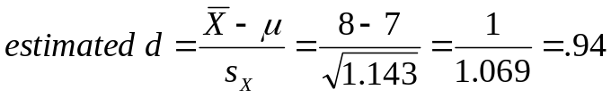

Step 8. Compute r² and write a conclusion.
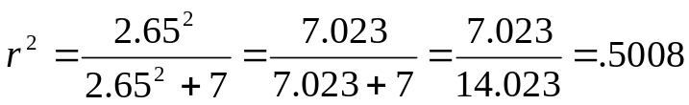

Approximately 50% of the variance in scores on the memory test can be attributed to Memory Booster.

or

Taking Memory Booster accounts for 50.08% of the variance in scores on the memory test.

